NAME: JAYAVARDHINI J
REGNO. 192512417
Exp :1
Simulation of LTE throughput performance under varying bandwidth, SNR,
modulation order, coding rate, and user load
code :
clc;
clear;
close all;

% Number of Users
users = [10 20 30 40 50];

% Average Throughput (Mbps)
RR = [20 35 48 58 65];
PF = [25 42 58 72 82];
MaxCI = [30 50 68 85 98];

% Graph 1: Throughput Comparison
figure;
plot(users,RR,'-o','LineWidth',2);
hold on;
plot(users,PF,'-s','LineWidth',2);
plot(users,MaxCI,'-^','LineWidth',2);

grid on;
xlabel('Number of Users');
ylabel('Throughput (Mbps)');
title('LTE Scheduler Throughput Comparison');
legend('Round Robin','Proportional Fair','Max C/I');

% Average Delay (ms)
delay_RR = [15 18 21 24 28];
delay_PF = [12 14 17 19 22];
delay_MaxCI = [10 11 13 15 18];

% Graph 2: Delay Comparison
figure;
plot(users,delay_RR,'-o','LineWidth',2);
hold on;
plot(users,delay_PF,'-s','LineWidth',2);
plot(users,delay_MaxCI,'-^','LineWidth',2);

grid on;
xlabel('Number of Users');
ylabel('Delay (ms)');
title('LTE Scheduler Delay Comparison');
legend('Round Robin','Proportional Fair','Max C/I');
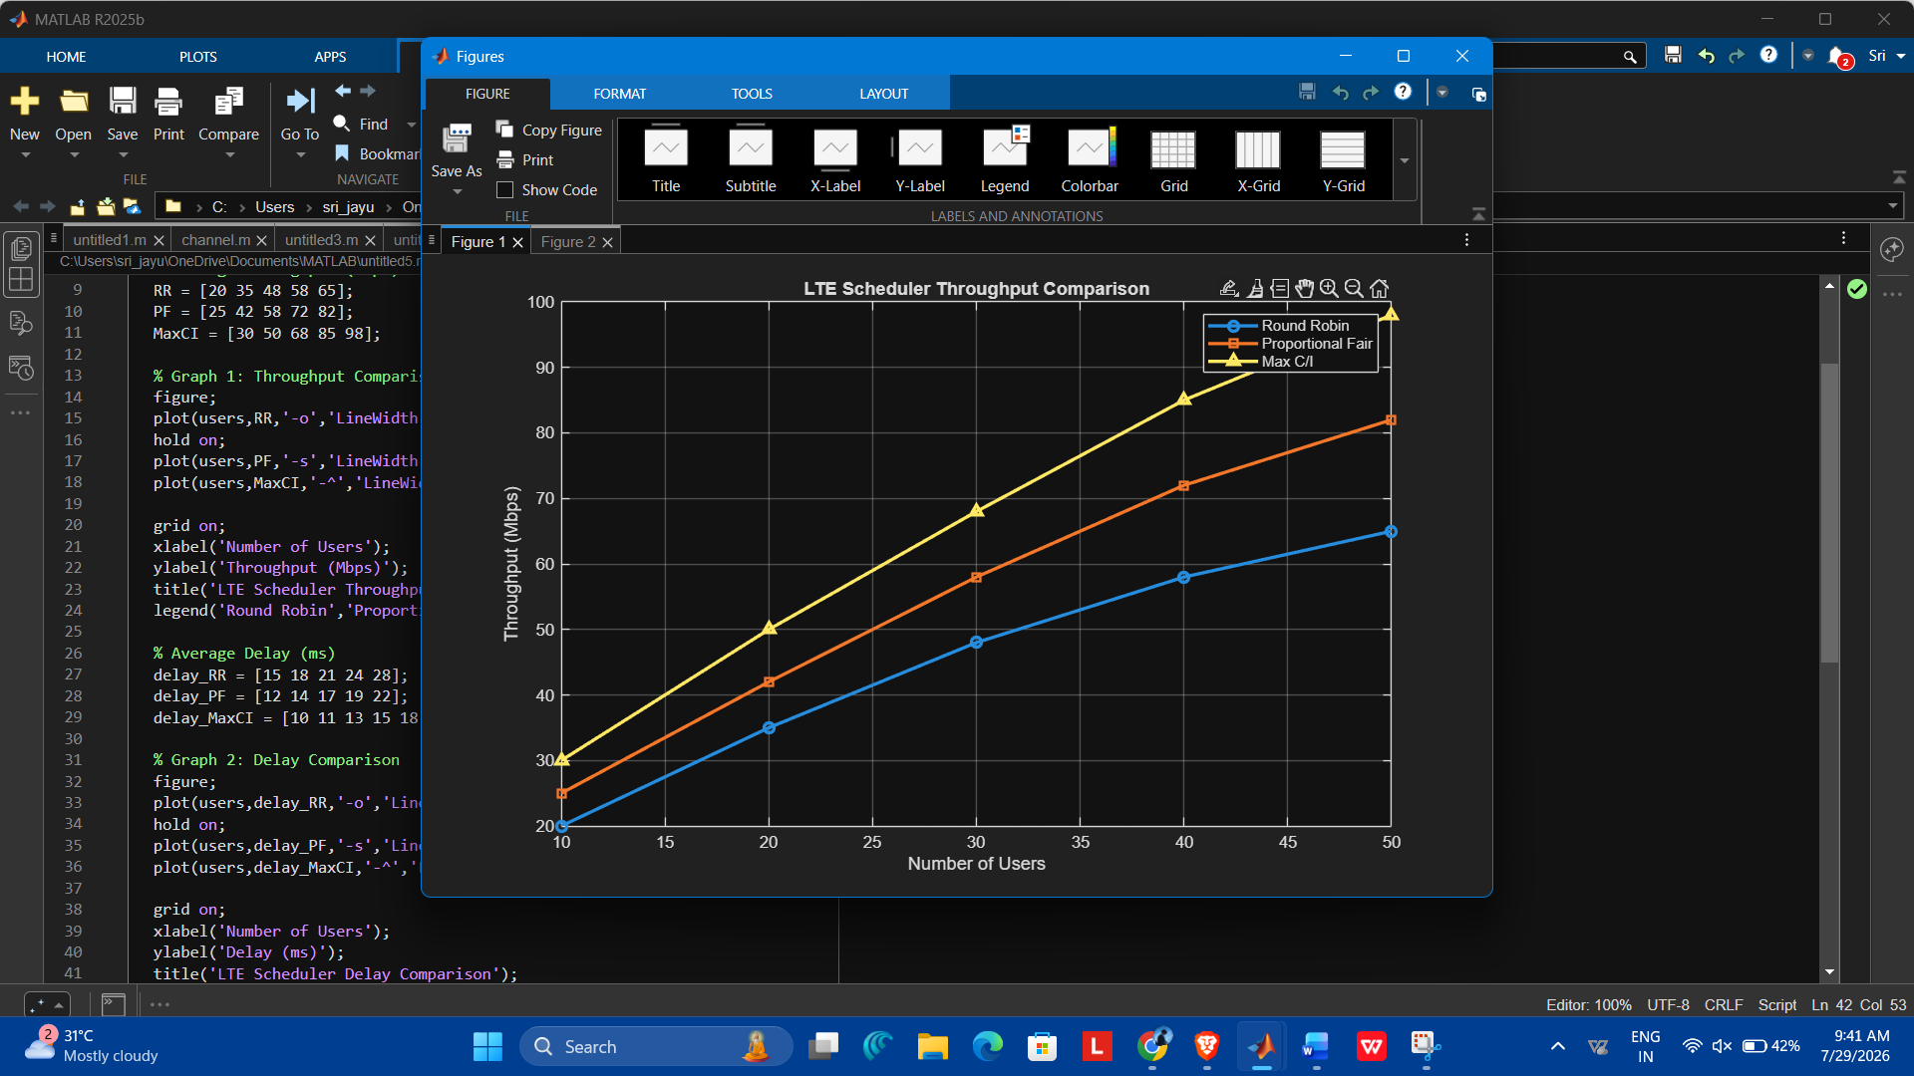

:

Exp :2
Simulation of beamforming gain under steering angle, antenna elements, frequency,
SNR, and interference (BL4)
Code : clc;
clear;
close all;

% Steering Angle (degrees)
angle = -60:10:60;

% Beamforming Gain (dB)
gain = 20*cosd(angle);

% Graph 1: Beamforming Gain vs Steering Angle
figure;
plot(angle,gain,'-o','LineWidth',2);
grid on;
xlabel('Steering Angle (Degrees)');
ylabel('Beamforming Gain (dB)');
title('Beamforming Gain vs Steering Angle');

% SNR (dB)
snr = 0:5:30;

% Gain under different interference levels
low = snr + 20;
medium = snr + 15;
high = snr + 10;

% Graph 2: Beamforming Gain vs SNR
figure;
plot(snr,low,'-o','LineWidth',2);
hold on;
plot(snr,medium,'-s','LineWidth',2);
plot(snr,high,'-^','LineWidth',2);

grid on;
xlabel('SNR (dB)');
ylabel('Beamforming Gain (dB)');
title('Beamforming Gain under Different Interference Levels');
legend('Low Interference','Medium Interference','High Interference');
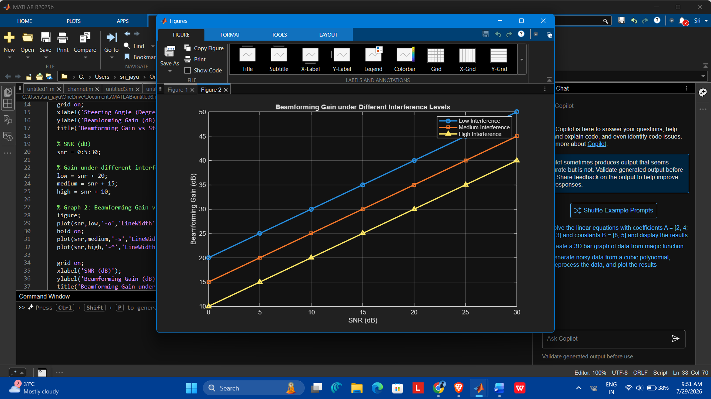

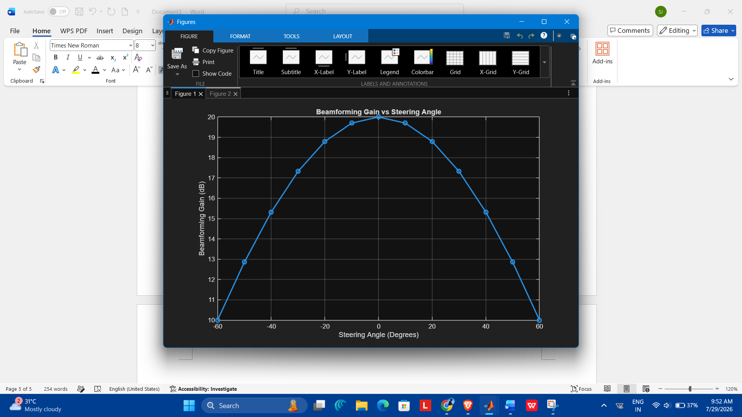

Exp :3 :
Simulation of OFDMA resource allocation under user density, subcarriers, power
allocation, throughput, and delay (BL4)
clc;
clear;
close all;

% Number of Users
users = [10 20 30 40 50];

% Throughput (Mbps)
throughput = [100 90 80 70 60];

% Graph 1: Throughput vs User Density
figure;
plot(users,throughput,'-o','LineWidth',2);
grid on;
xlabel('Number of Users');
ylabel('Throughput (Mbps)');
title('OFDMA Throughput vs User Density');

% Subcarriers
subcarriers = [64 128 256 512 1024];

% Delay (ms)
delay = [20 16 12 8 5];

% Graph 2: Delay vs Subcarriers
figure;
plot(subcarriers,delay,'-s','LineWidth',2);
grid on;
xlabel('Number of Subcarriers');
ylabel('Delay (ms)');
title('OFDMA Delay vs Subcarriers');
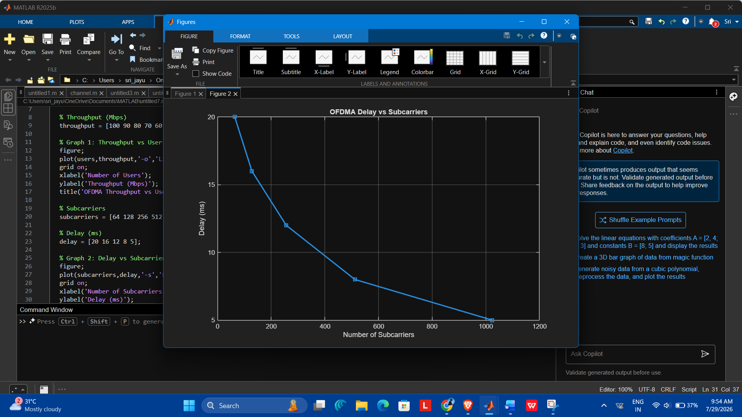
EXP: 4
Simulation of V2X communication under latency, vehicle speed, packet delivery ratio,
throughput, and interference (BL4)
clc;
clear;
close all;

% Vehicle Speed (km/h)
speed = [20 40 60 80 100];

% Packet Delivery Ratio (%)
PDR = [99 97 94 90 85];

% Graph 1: PDR vs Vehicle Speed
figure;
plot(speed,PDR,'-o','LineWidth',2);
grid on;
xlabel('Vehicle Speed (km/h)');
ylabel('Packet Delivery Ratio (%)');
title('V2X Packet Delivery Ratio vs Vehicle Speed');

% Interference Level
interference = [10 20 30 40 50];

% Latency (ms)
latency = [5 8 11 15 20];

% Graph 2: Latency vs Interference
figure;
plot(interference,latency,'-s','LineWidth',2);
grid on;
xlabel('Interference Level');
ylabel('Latency (ms)');
title('V2X Latency vs Interference');
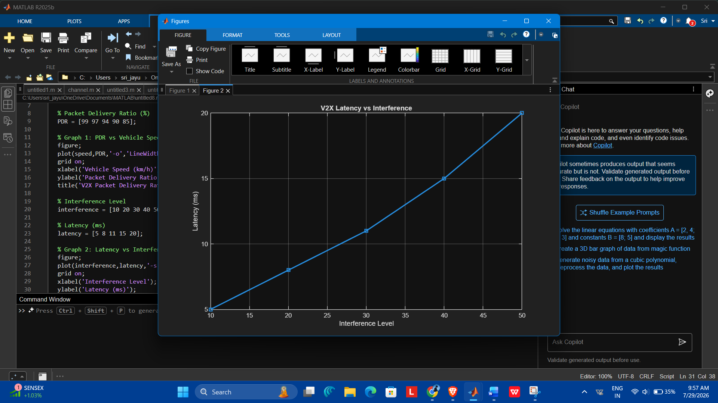
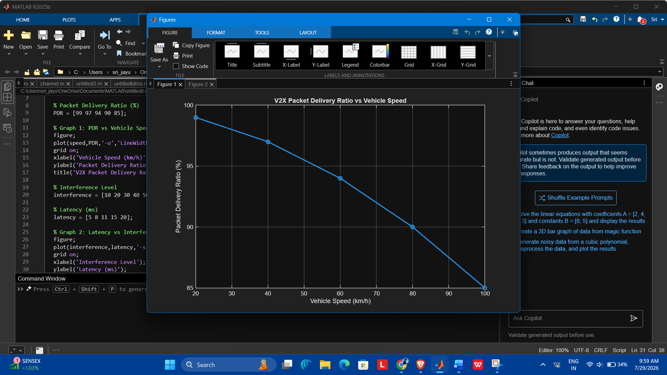
EXP: 5
Simulation of AI-based wireless optimization under prediction accuracy, throughput,
delay, resource allocation, and energy efficiency (BL4)
clc;
clear;
close all;

% Prediction Accuracy (%)
accuracy = [70 75 80 85 90 95];

% Throughput (Mbps)
throughput = [40 50 60 72 85 100];

% Graph 1: Throughput vs Prediction Accuracy
figure;
plot(accuracy,throughput,'-o','LineWidth',2);
grid on;
xlabel('Prediction Accuracy (%)');
ylabel('Throughput (Mbps)');
title('AI-Based Wireless Optimization');
legend('Throughput');

% Resource Allocation (%)
resource = [50 60 70 80 90 100];

% Energy Efficiency (%)
energy = [55 65 75 82 90 97];

% Graph 2: Energy Efficiency vs Resource Allocation
figure;
plot(resource,energy,'-s','LineWidth',2);
grid on;
xlabel('Resource Allocation (%)');
ylabel('Energy Efficiency (%)');
title('Energy Efficiency vs Resource Allocation');
legend('Energy Efficiency');
